Database Management System Project

SupplyX

* Documentation

Bava Viknesh R M G Saikumarran S K Sujith Vishal V

2020103512 2020103561 2020103572

**Abstract:**

There are often instances in real life where manufacturers need to open warehouses in multiple locations to meet faster and easier delivery of products. To open a warehouse of its own has its own logistics and expense issue. So, manufacturers go for 3rd party companies who offer warehouses of their own. This leads to the stocking up of manufacturers’ products in multiple locations at cheaper rates. These companies also provide transportation of ordered products, as some products might not be available at all locations and need to be transported only when needed. If the manufacturers had their own warehouses and had to transport some products from one location to another, there might arise a situation where the stocks are less and the space that could be accommodated by the transport vehicle is empty at large. This leads to a waste of fuel and time. The 3rd party companies could collate the stocks of all the contracted manufacturers and assign them a single vehicle for transport, which leads to efficient use of fuel and time. The 3rd party companies need to have a dedicated supply chain management system to avoid discrepancies among the various manufacturers and their products and also maximize their transport path efficiency as required.

**Introduction:**

Crowdfunding harnesses the power of social networks and the internet to give people the means to raise funds, help others overcome hardship, and meet aspirational goals. The core principle behind the crowdfunding definition is that you can help a friend or help an entire community. You can do everything from pay to fulfil a student’s dream of attending college—and so much more.

Pressing financial needs arising out of unprecedented emergencies can almost always be demanding. So we provide a platform to get the financial needs of the individuals for medical, education purposes and for start-ups from philanthropist and others who are willing to donate. Since availing a loan for a huge amount from the bank or getting investments from sharks is time consuming one and is not very easy. So we help the people who are in need of fund by providing a means of link with which the can interact with the people who are willing to donate and help the entire society. And we also provide security constraints so that the people who are donating is ensured that they haven't get into scams due to unverified information. We ensure the each of them signed into our site has been verified using their bank account and personal details. We allow the persons who are in need to raise a fund by advertising in our site. And the one who is willing to donate would be able to read the advertisement posted by them and if the feel to provide the amount they could do so.

By using the power of the online community, it can also be a way of cultivating a community around your offering. It can be a fast way to raise finance with no upfront fees. It enables communication among supporters and campaign organizers. Crowdfunding enables start-ups, small businesses and innovative ideas to get financial backing. It is a great way of raising finance and covering costs for those businesses without access to traditional forms of bank lending or in a difficult economy. It’s more efficient than traditional fundraising. It’s a place to build traction, social, proof, and validation. Starting up a company is very risky and challenging journey. Besides finding sufficient funding, there are always expenses that are impossible to forecast. Launching a crowdfunding campaign hedges these risks and serves as a valuable learning experience. By having a crowdfunding campaign, the entrepreneur has the ability to engage the crowd and receive fund to improve his/her ideas. Thereby we are making the jobs easy for them.

**Advantages:**

* There is no application process.
* There are no long wait periods to receive your funds.
* Crowdfunding takes the fear out of asking for financial help. It’s simple to share your fundraiser with your network of friends and family members on social media.
* Crowdfunding makes it easy to reach people outside of your network.

**Description:**

Crowdfunding is a financing method that involves funding a project with relatively modest contributions from a large group of individuals, rather than seeking substantial sums from a small number of investors.

Pressing financial needs arising out of unprecedented emergencies can almost always be demanding. So we provide a platform to get the financial needs of the individuals for medical, education purposes and for start-ups from philanthropist and others who are willing to donate.

We allow users to request fund for their needs through our platform by allowing them to post their statement of need and we will get that to be noticed by everyone. On creation of new user they will be allowed to raise fund through a post but others can only be able to see the post after the admin verifies the profile and the post, then it is made available for others to donate the fund. This protect the users from spam who are donating. We manage a number of transactions that is made between two users such as that one user made a post and raised a fund to about 1, 00,000 and other users who wish to donate may able to see the post only when the admin verifies it and there has to be a minimum limit set to the post so that at least a small amount reaches to the one who has made the request. So the user who is willing to donate then donates some amount based on the wish and the fund reaches the individual who requested.

Every individual can donate as well as raise fund through our platform thus helps in building a strong community inside our domain. By using the power of the online community, it can also be a way of cultivating a community around your offering. It can be a fast way to raise finance with no upfront fees. It enables communication among supporters and campaign organizers. It is a great way of raising finance and covering costs for those businesses without access to traditional forms of bank lending or in a difficult economy. It’s more efficient than traditional fundraising.

The admin user manages the number of users signed into our website and number of post made by individual user and how frequently a user creates multiple post. Therefore if a user raises for fund through many post their post should not be validated this is done by the administrator with data of how frequently a user creates a post. Thereby providing the risk free functionality to the users.

It is simple to raise funds within your network and but we would also allow it to reach outside of your network. It therefore takes the fear out of asking for financial help. Thereby we are making the jobs easy for them.

**ER Diagram:**

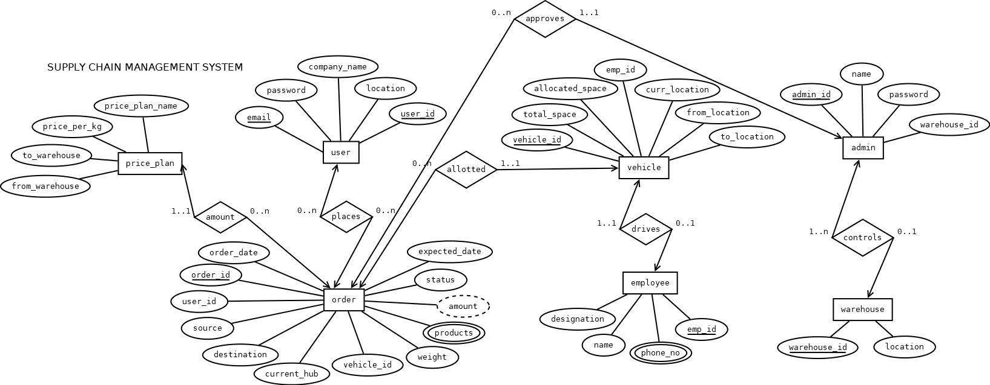

**Database Description:**

Database (RDBMS):

MySQL, MySQLWorkbench

**Tables and Attributes:**

|  |  |
| --- | --- |
| **Table Name** | **Attributes** |
| Admins | Admin_id (primary key)  Name  Password  Warehouse_id (foreign key) |
| Users | User_id (primary key)  Email  Password  Company_name  Location |
| Orders | Order_id (primary key)  Order_date  User_id (foreign key)  Source (foreign key)  Destination (foreign key)  Current_hub (foreign key)  Vehicle_id (foreign key)  Weight  Products  Amount  Status  Expected_date |
| Warehouses | Warehouse_id (primary key)  Location |
| Price_plans | From_warehouse (foreign key)  To_warehouse (foreign key)  Price_per_kg  Price_plan_name |
| Vehicles | Vehicle_id (primary key)  Total_space  Allocated_space  Emp_id (foreign key)  Curr_location (foreign key)  From_location (foreign key)  To_location (foreign key) |
| Employees | Emp_id (primary key)  Name  Designation  Phone_no |

**Relationships:**

|  |  |
| --- | --- |
| **Relationship name** | **Table name** |
| Places | Users to Orders |
| Allotted | Orders to Vehicles |
| Controls | Admins to Warehouses |
| Approves | Admins to Orders |
| Amount | Price_plans to Orders |

**Stack:**

Frontend: ReactJS, MaterialUI

Backend: NodeJS

Database: MySQL

**Results:**

**Login:**

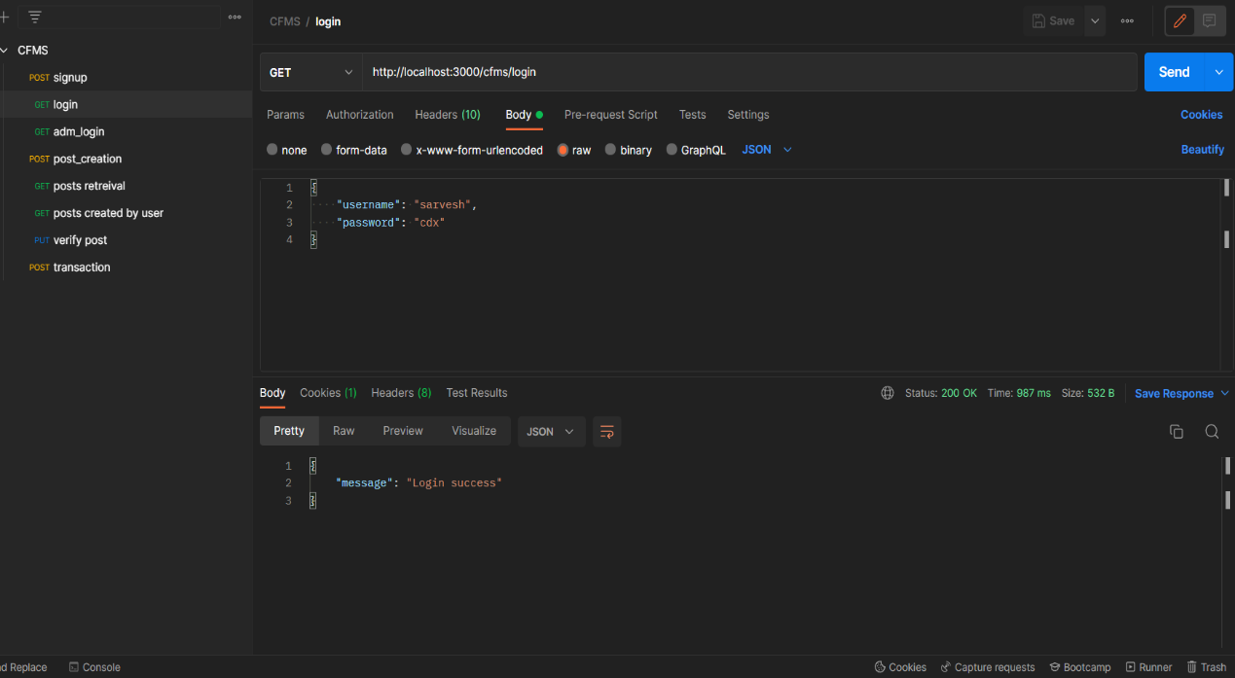

Helps to verify the user credentials and allow only registered users to get into our site. It fetches the data from the database (backend). Then checks whether the user and the password matches with the existing ones.

**Post Creation:**

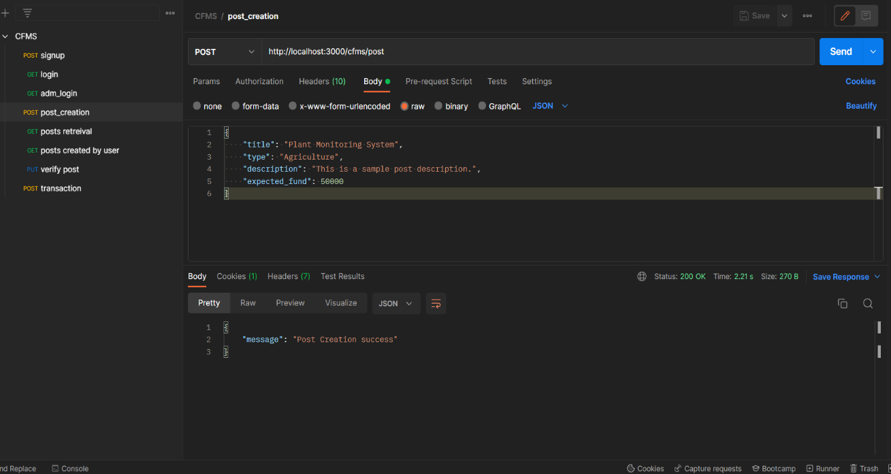

On entering the required details for the post description helps to create and publish them to the field. So that on successful creation of the post it is made available to the global feed so that it is visible to other users can able to donate if they wish to.

**Post Retrieval:**

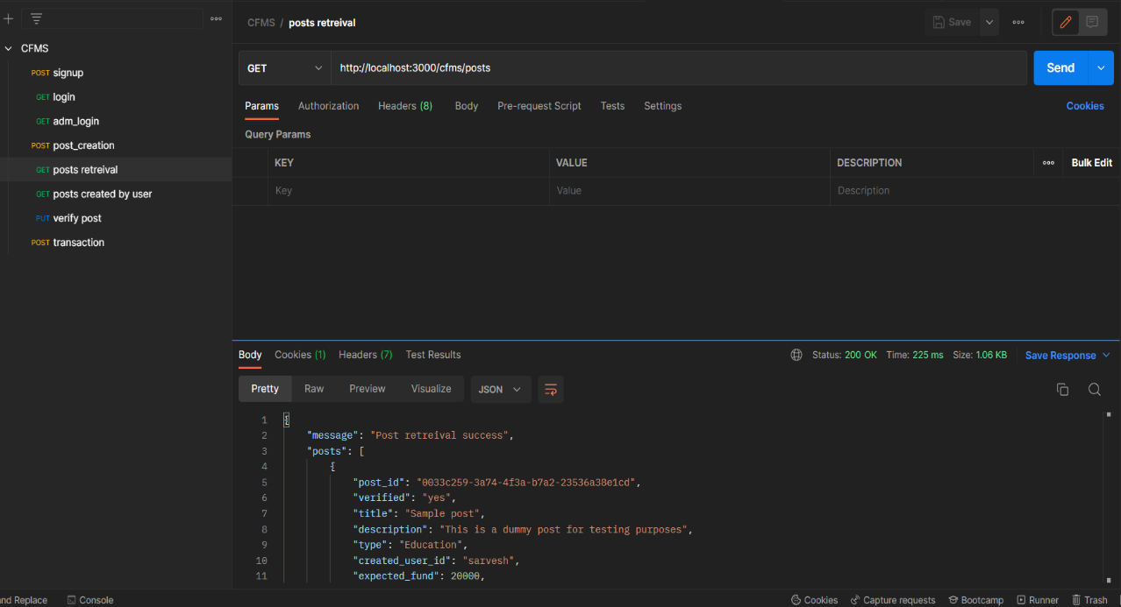

Helps to get the all posts from the database to display them globally to the other users in the post section this is global feed available to every users.

**Post Verification:**

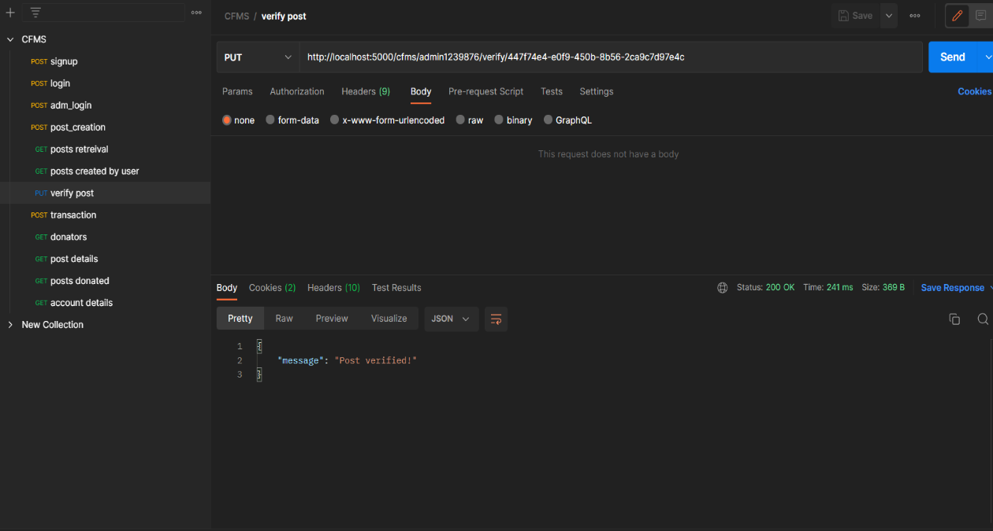

On creation of new user they will be allowed to raise fund through a post but others can only be able to see the post after the admin verifies the profile and the post.

**Donation:**

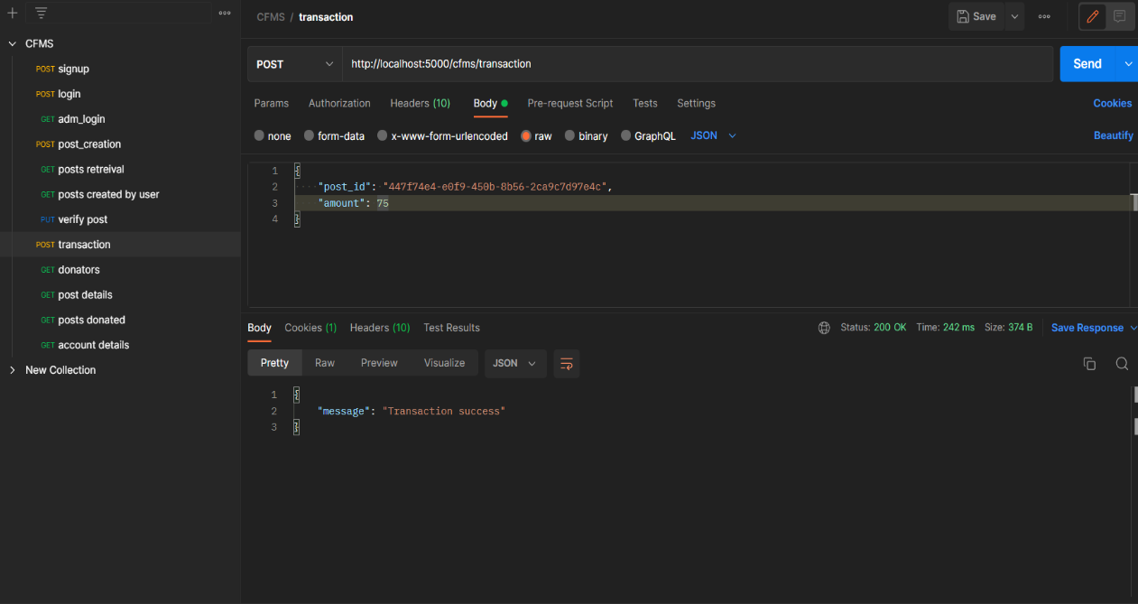

Any user with an account can donate to the verified post which he/she likes to contribute.

**Trigger:**

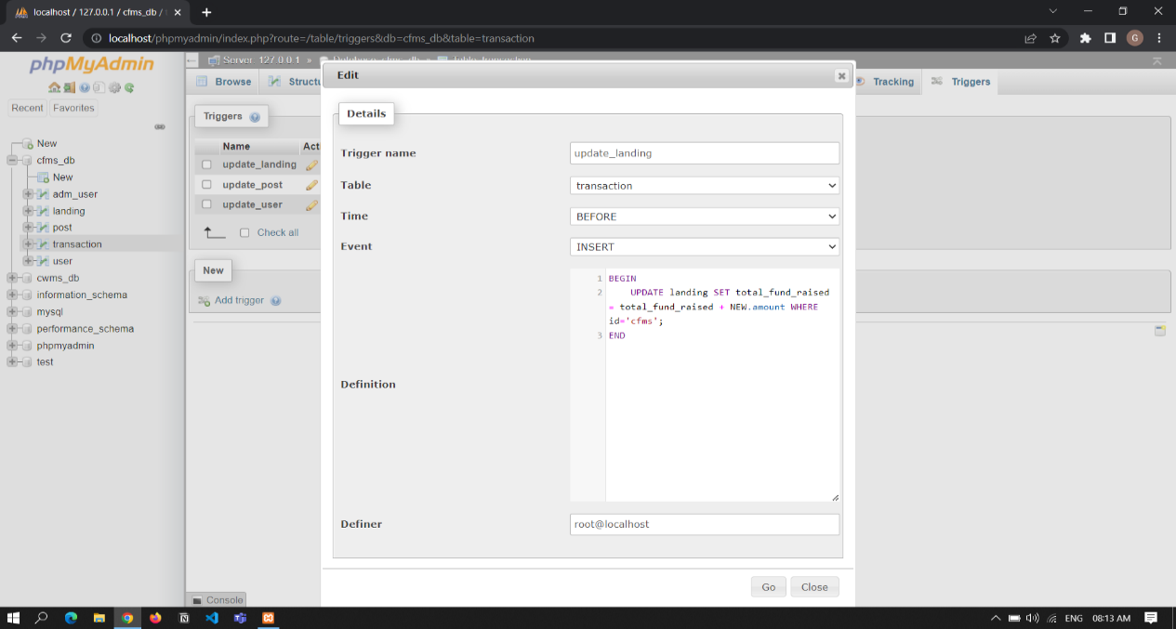

Before landing to the home page the total amount raised or funded through our site has to be update. So this trigger updates the landing page whenever there happens a transaction. Thereby this process is automated.

**Database Tables:**

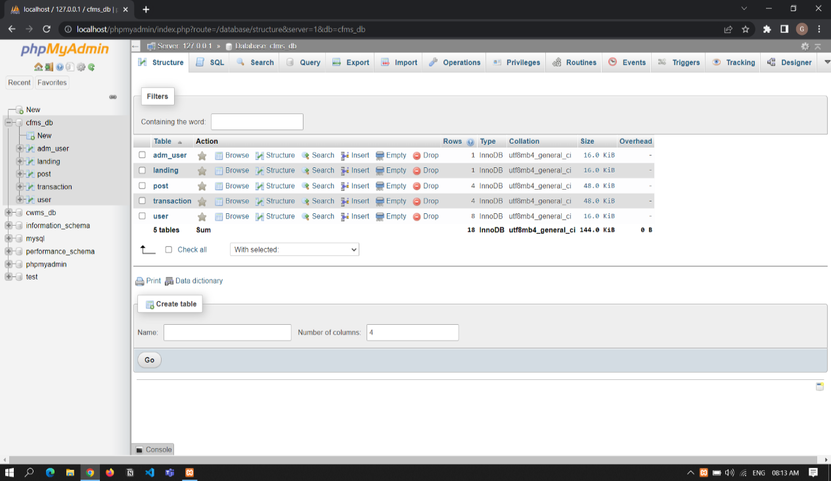

The tables we created to manipulate data across our web application.

A separate table for the admin user and the for the landing page details. This is ensure admin user details being isolated from other tables. The landing table contains the statistics to be displayed in the landing page. And a user table to store the details of the registered users, their passwords and other details. Then two separate tables for the transactions and the post each individual user has made. This contains which user made which post and which user donated to which post and how much had been transacted.

**Data Storage:**

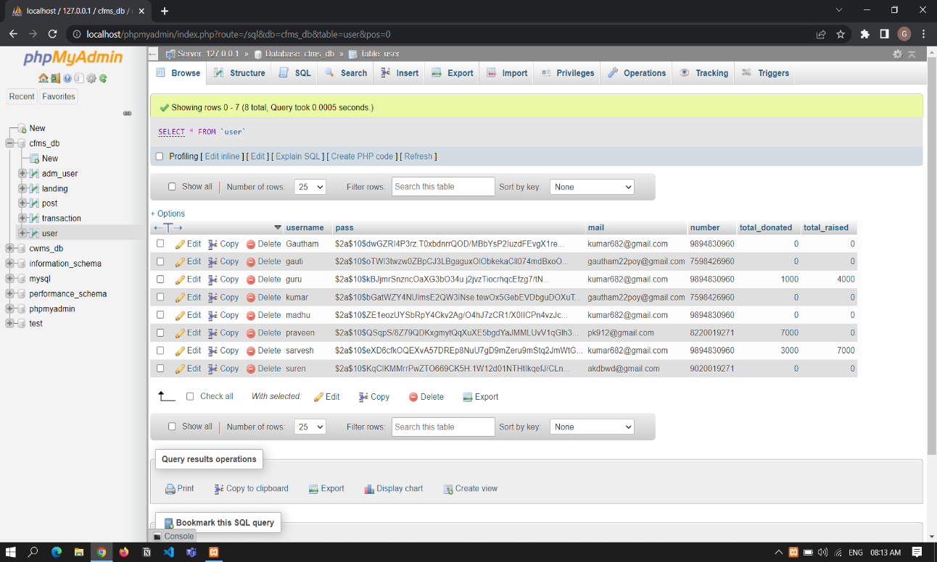

The user credentials and personal details gets stored to user details table so when a user logs in using the credentials the data is fetched from the database and it is verified with the given one.

**Conclusion:**

We Provide SaaS (Software-as-a-Service) to accommodate the needs of a Supply Chain Management Company. We cater to them by providing them with an out-of-the-box solution, with all their typical execution and administration needs taken care of. By subscribing to our product, they avoid the need for a dedicated tech team to develop and debug a tailor-made management system software.

**References:**

**ReactJS:** <https://reactjs.org/>

**MaterialUI:** [https://mui.com/material-ui/](https://mui.com/material-ui)

**NodeJS:** <https://nodejs.org/en/docs/>

**MySQL:** <https://dev.mysql.com/doc/>